Math 231 Test #2

Your Name:

Please circle your discussion group (2 pt)

|  |  |  |
| --- | --- | --- |
| 1 Gan Yinliang B416 | 4 Zhang Jinghao B425 | 7 Loigen Sodian B416 |
| 2 Zhang Junwei B424 | 5 Xu Hang B419 |  |
| 3 Ke Wentao B419 | 6 Huang Nuoer B410 |  |

* You will have one hour for the exam.
* No notes, books or electronics during the exam.
* Do not open this test booklet until a proctor says start.
* For all free response questions, show work that justifies your answer.
* Raise your hand if you have a clarification question.
* Scratch paper is provided. You can ask for more if needed.
* Do not leave early: this disturbs others. If you finish your test early, check your work

or just relax.

* Quit working when the test ends and hand your test booklet to proctors.

|  |  |  |  |  |  |  |  |  |  |  |
| --- | --- | --- | --- | --- | --- | --- | --- | --- | --- | --- |
| Question | 1 | 2 | 3 | 4 | 5 | 6 | 7 | 8 | 9 | Total |
| Points | 12 | 14 | 25 | 7 | 8 | 10 | 6 | 10 | 6 | 98 |
| Score |  |  |  |  |  |  |  |  |  |  |

1. (12 points, 3 points each) Determine whether the statement is true or false. Circle the right answer.
2. If $\sum{a_{n}}$ is divergent, then $\sum{|a_{n}|}$ is divergent. (True or False)
3. If $\{a_{n}\}$ and $\{b_{n}\}$ are divergent, then $\{a_{n}+b_{n}\}$ is divergent. (True or False)
4. If $\{a_{n}\}$ is decreasing and $a_{n}>0$ for all $n$, then $\{a_{n}\}$ is convergent. (True or False)
5. If $f\left(n\right)=a_{n}, \lim_{n→∞}{a_{n}=L}$ then $\lim_{n→∞}{f(x)=L}$. (True or False)

2. (14 pts) Use integral test to test the following series.

(a)

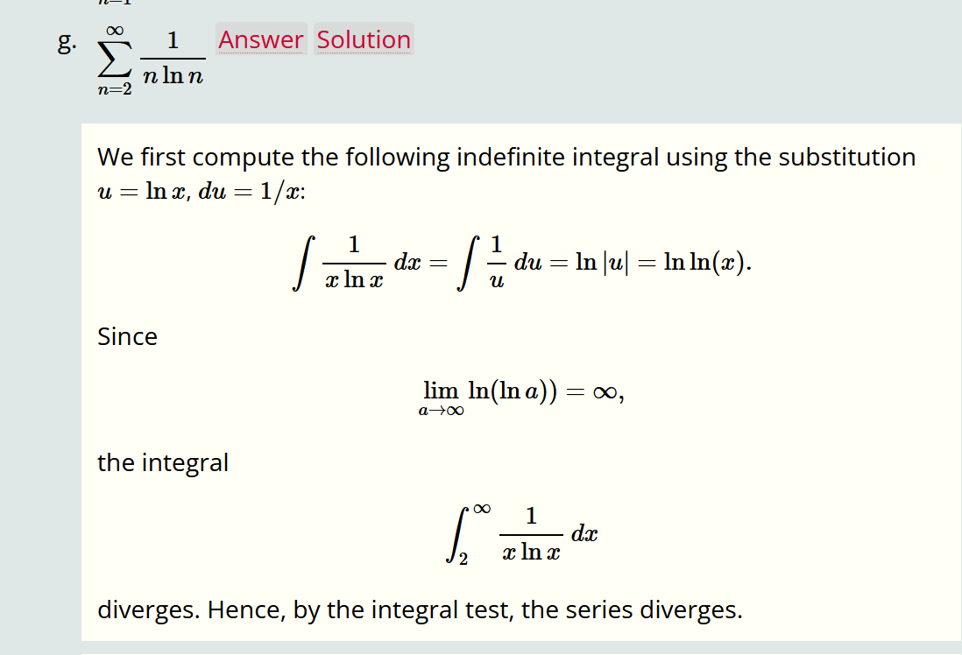

(b)

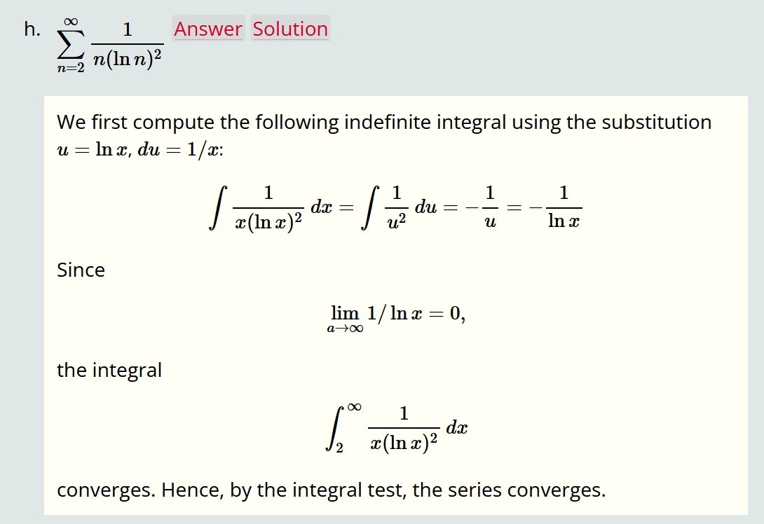

3. (25 pts) Please choose proper series test to decide whether the series is convergent or divergent. Justify your answer.

(a) $\sum_{n=1}^{∞}{\frac{1}{n^{1+1/n}}}$

Diverge. Limit comparison test compare with

(b)

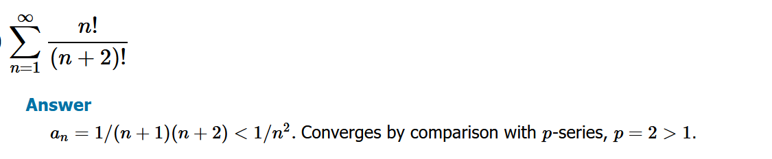

(c)

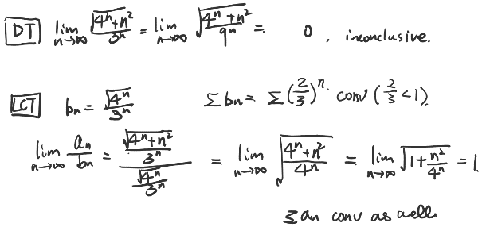

(d)

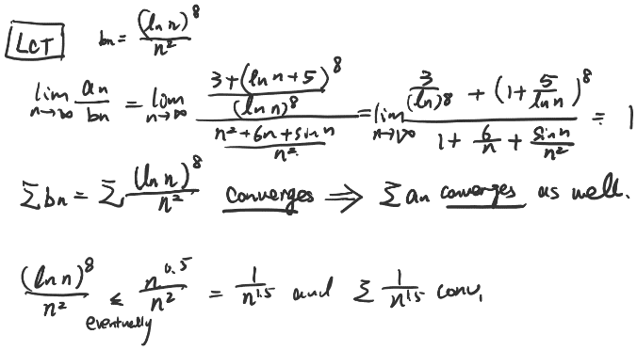

(e)

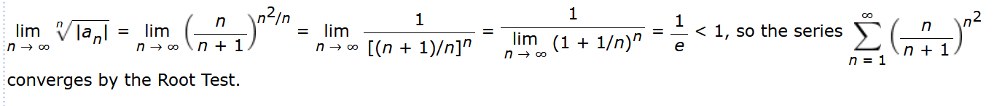

4. (7 pts) Find a function $f(x)$ whose arc length $L(x)$ from to , is

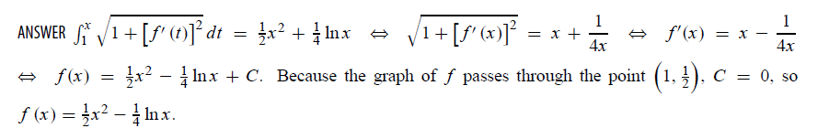

5. (8 pts) Determine whether the following series are absolutely convergent, conditionally convergent or divergent.

(a) 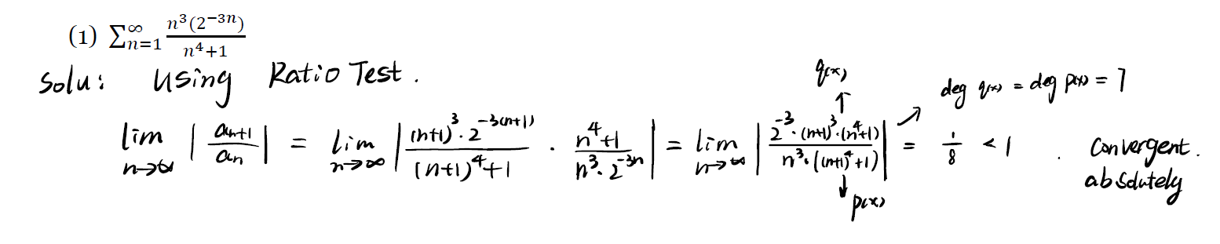

(2)

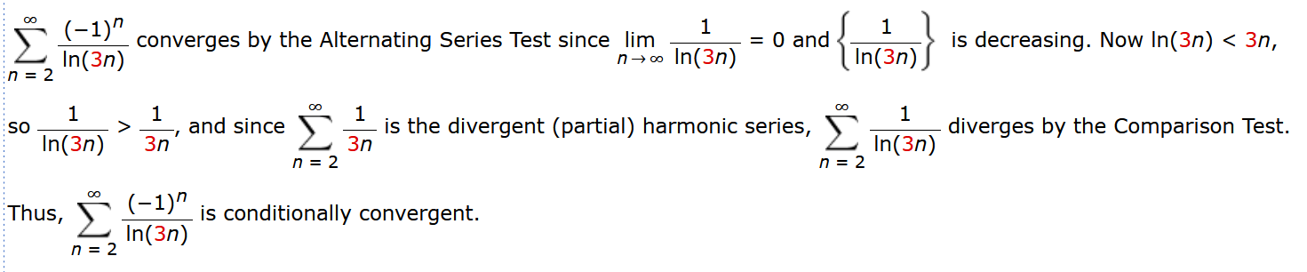

6. (10 pts) A trough with a trapezoidal cross-section, as shown in the figure, contains vegetable oil with density $1000 kg/m^{3}$. Find the hydrostatic force on one end of the trough if it is completely full of oil. ()

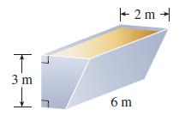

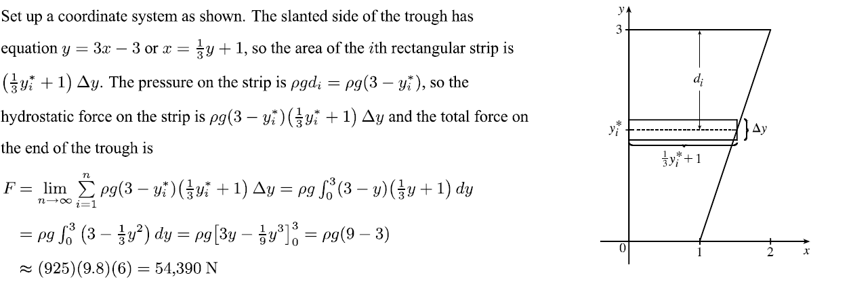

7. (6 pts) Let $\{b_{n}\}$ be a sequence of positive umbers that converges to $\frac{1}{2}$. Determine whether the given series $\sum_{n=1}^{∞}{\frac{b_{n}^{n}\cos{nπ}}{n}}$ is absolutely convergent.

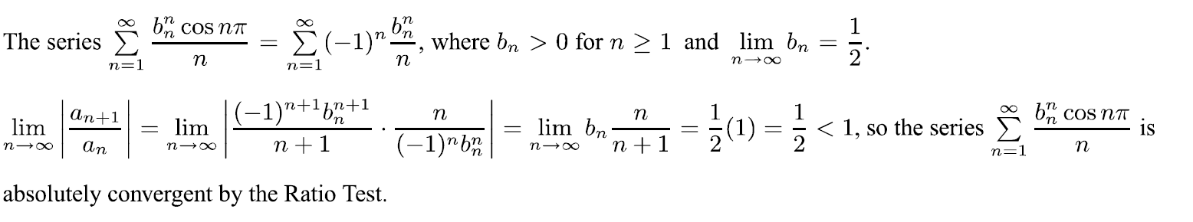

8. (10 pts) is rotated about the x-axis. Set up, but do not evaluate, an integral for the area of the resulting surface.

(a) by integrating with respect to x

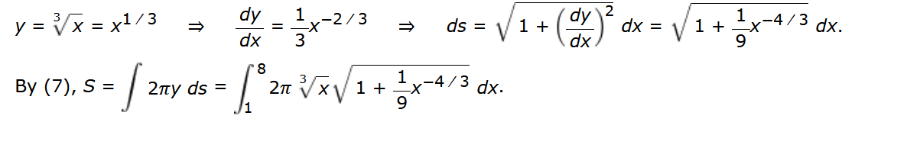

(b) by integrating with respect to y

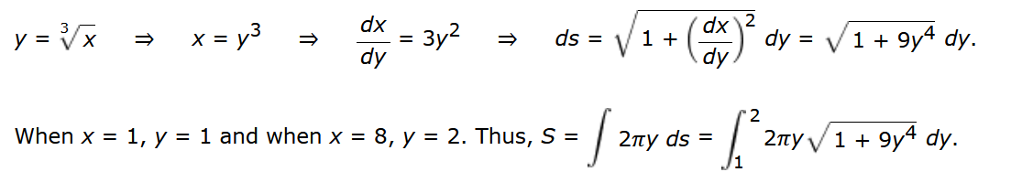

9. (6 pts) (a) Approximate the sum of the series $\sum_{n=1}^{∞}{\frac{1}{n^{3}}}$ by using the first 2 terms.

(b) Estimate the maximum error in this approximation.

(a) $S_{2}=1+\frac{1}{8}=1.125$

(b) $\int_{2}^{∞}{\frac{1}{x^{3}}=1/}8$